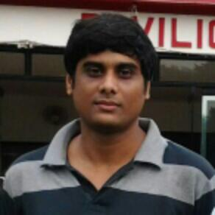

Mr. Debraj Das

M.Sc.(C.U.)

Assistant professor

Date of joining in W.B.E.S. : 2ND June,2015

**About me**

**Email id  :** debraj.das84@gmaill.com  
  
**Teaching Experience  :** 11 years  
  
**Research experience  :** 4 years.  
  
**Area of specialization  :**  Econometrics & Statistics, Political Economy  
  
**Research Area  :** Agricultural Economics

**Publications**

* Sarker,D,Das,D(2011): “Institution of Politically Motivated Policy Certainty of Government on Economic Growth: A Study among Major Indian States”, Political Economy Journal of India, Volume 20,Issues 1 &2,Journal of Centre for Indian Development Studies, New Delhi.
* Sarker,D,Das,D(2011): “Review of Prime Policy Objectives in West Bengal”, Contributions to Indian Social Science, IASSI Quarterly, Volume 30,Jan-March 2011,No. 1, Journal of Indian Association of Social Science Institutions, New Delhi.
* Sarker,D,Das,D(2011): “Performance of Manufacturing Industry in Indian States: Who Loose and Why?”,The Journal of Institute of Public Enterprise, Vol 34,No 1 &2, Jan- June 2011, Institute of Public Enterprise, Osmania University, Hyderabad.
* Sarker,D,Das,D(2012): “Theory and Empirics of Economic Inequality Influencing Economic Growth: A Study of Major Indian States”, International Business Research, Vol 5,No 8, 2012, Canadian Centre of Science and Education,Canada.

**Paper Presentation in Seminars**

* Presented a paper entitled “Price Volatility of Agricultural Commodities in India: An Exploratory Econometric Analysis” in a National Level Management Doctoral Colloquium Organized By IIFT, Kolkata on 2nd December, 2011.
* Presented a paper entitled “An Analysis of the Price Behaviour of Agricultural Commodities in India” in an International Conference Organized By The Department of Economics, University of Calcutta on 20th January,2023.
* Presented a paper entitled “General Equilibrium Model of India’s Trade” in a UGC Sponsored State Level Workshop Organized By The Department of Economics, Chandernagore College on 16th December, 2011.
* Presented a paper entitled “Institution of Politically Motivated Policy Certainty of Government on Economic Growth: A Study among Major Indian States” in a UGC Sponsored National Level Workshop Organized By Centre for Economic Studies, The Department of Economics, Presidency University on 10th December,2010