Aloke Kumar Das
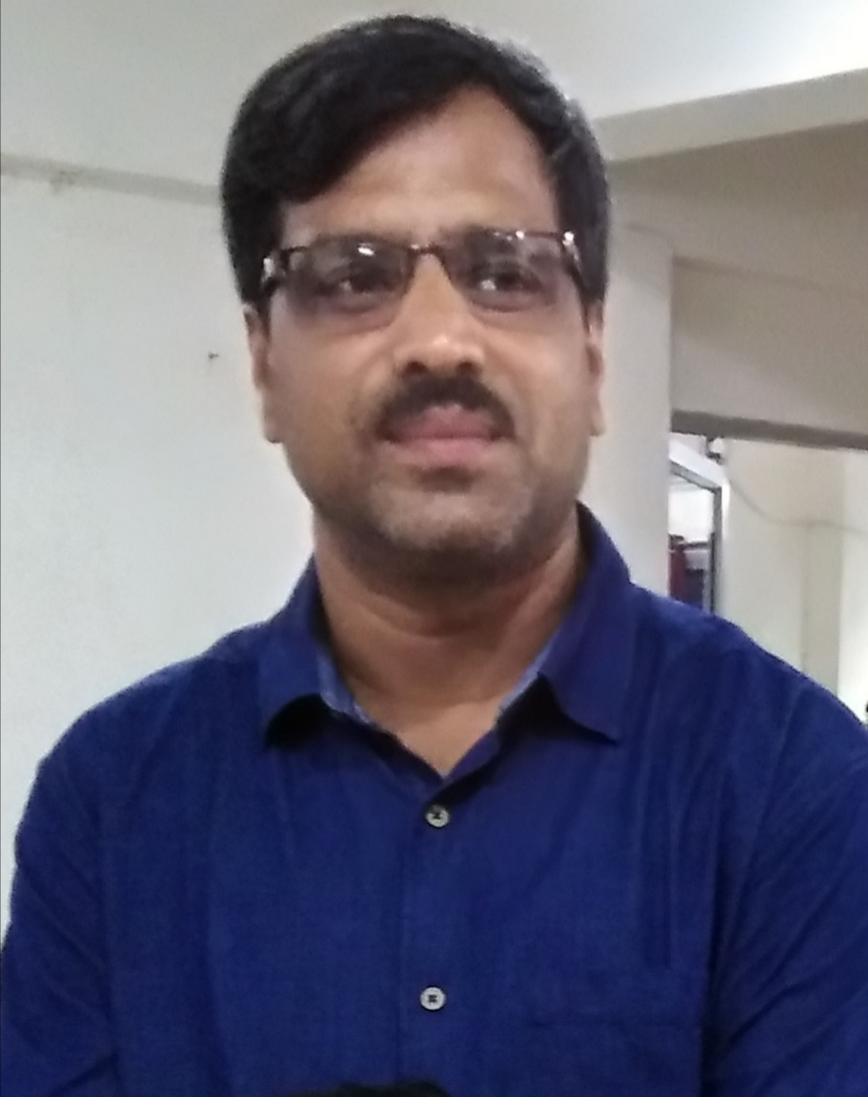
M. Sc.,B.Ed. (Burdwan University)
[Assistant Professor of Physics and Officer-in-Charge]

Joined W.B.E.S in
Darjeeling Govt. College in September, 2010
Durgapur Govt. College in April, 2015
Kabi Jagadram Roy Govt. General Degree College in June, 2015

Contact
E-mail: | alokekumardas.das37@gmail.com
Research Interest
- Planetary Atmosphere and Exoplanets.

Papers presented in Conferences, Seminars and Workshops
- Presented papers in two National, two International and one State level Conferences.
- Presented paper in TEQIP-II sponsored programme at NITD in May, 2016.

Additional Charge
- Took Charge of Kabi Jagadram Roy Government General Degree college, Mejia on 29th August 2019.

